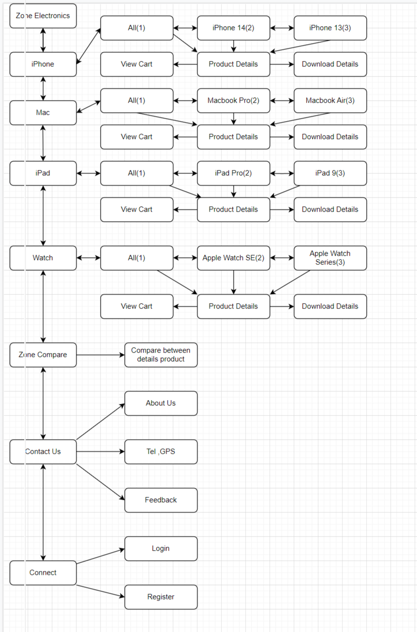**SITE MAP**

**SCREEN SHOTS**

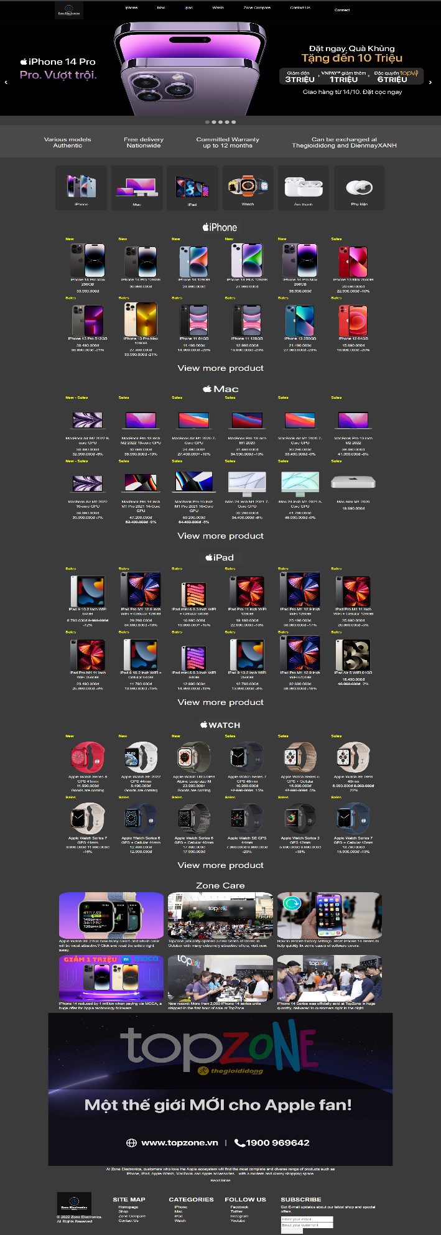**I/Homepage:**

**Description:**

**Homepage displays the following information:**

_ Slideshow picture, Menu of product, Zone Compare, Contact Us, Connect.

_ Responsive Web

_ iPhone product.

_ Mac product.

_ iPad product.

_ Watch product.

_ Zone blog.

_ Some information about website.

_ Footer.

**II/Shop:**

**Description:**

**This shop page displays the following information:**  
- All products that are sold at Shop when clicking on the product, will  
show the detail of that item.  
- Menu filter to easily find items based on Categories, Type, and Brand.  
- Product can sort by type.

* Can download product details.

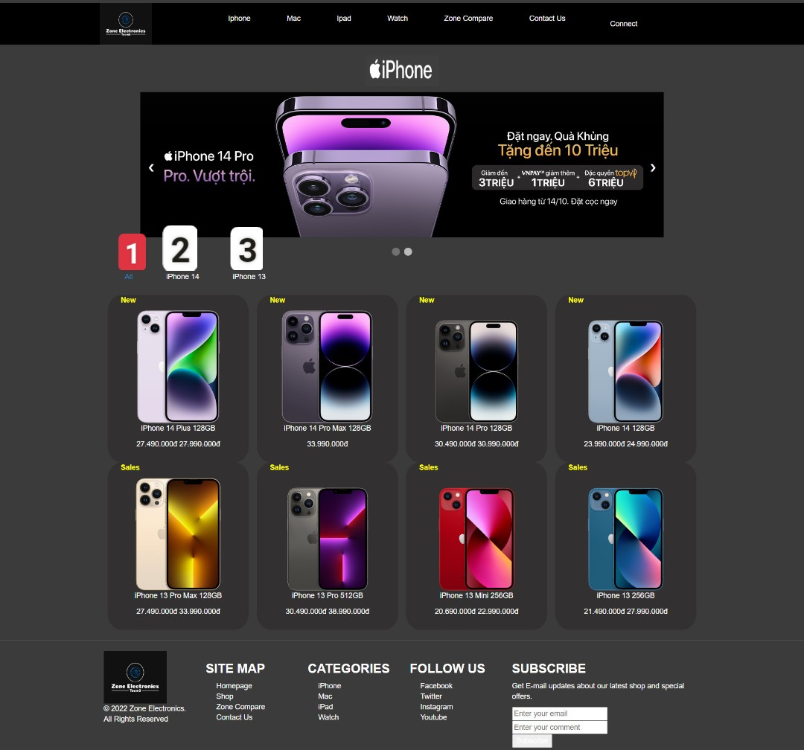**iPhone**

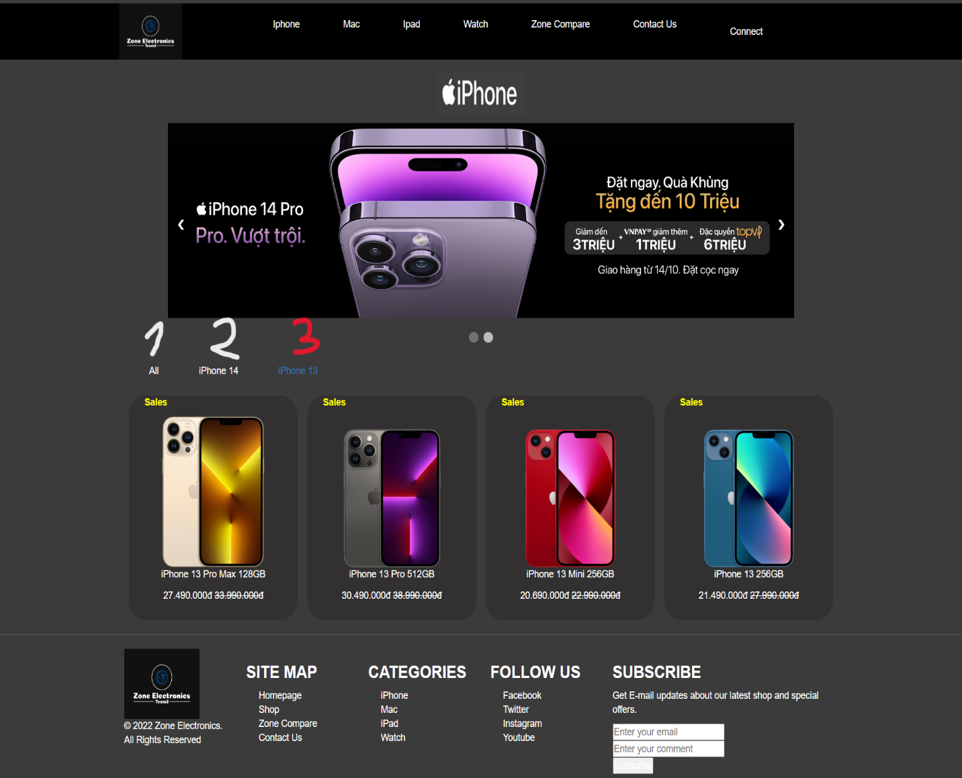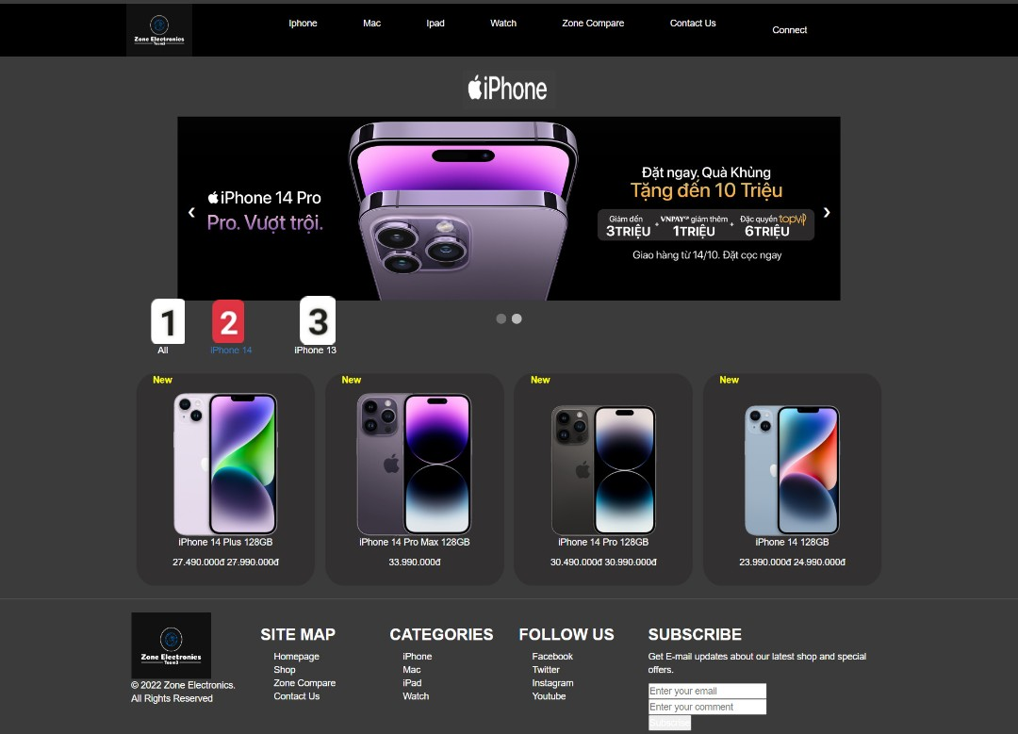

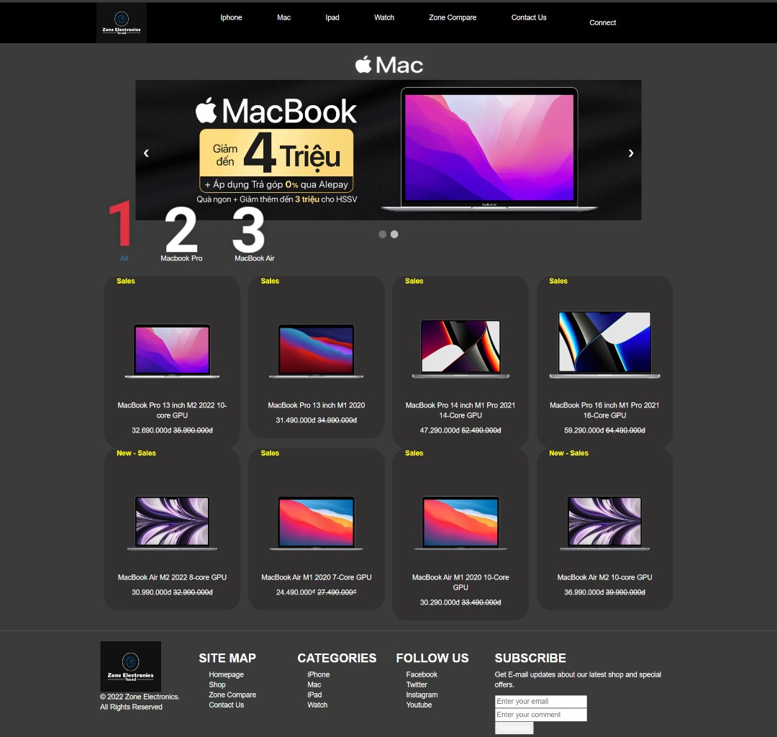**Mac**

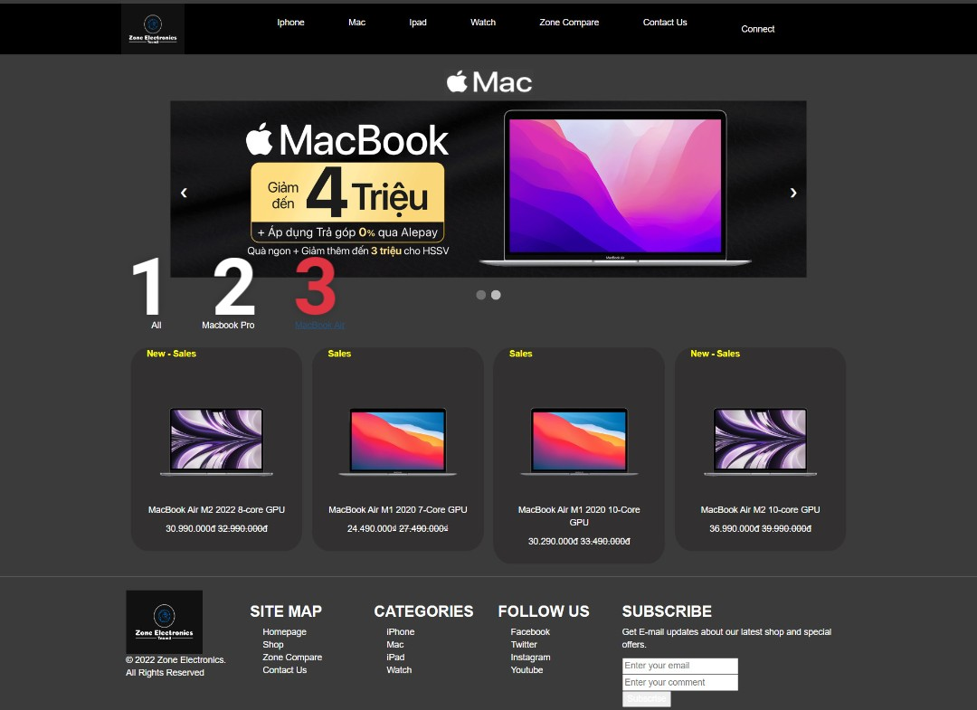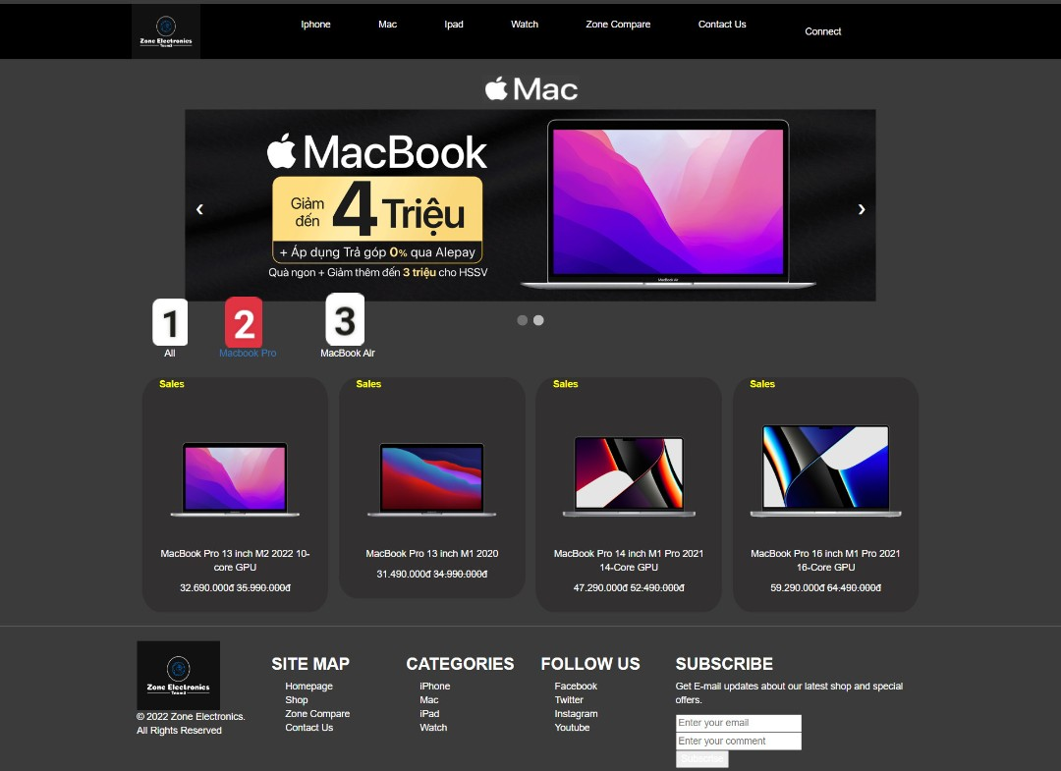

**iPad**

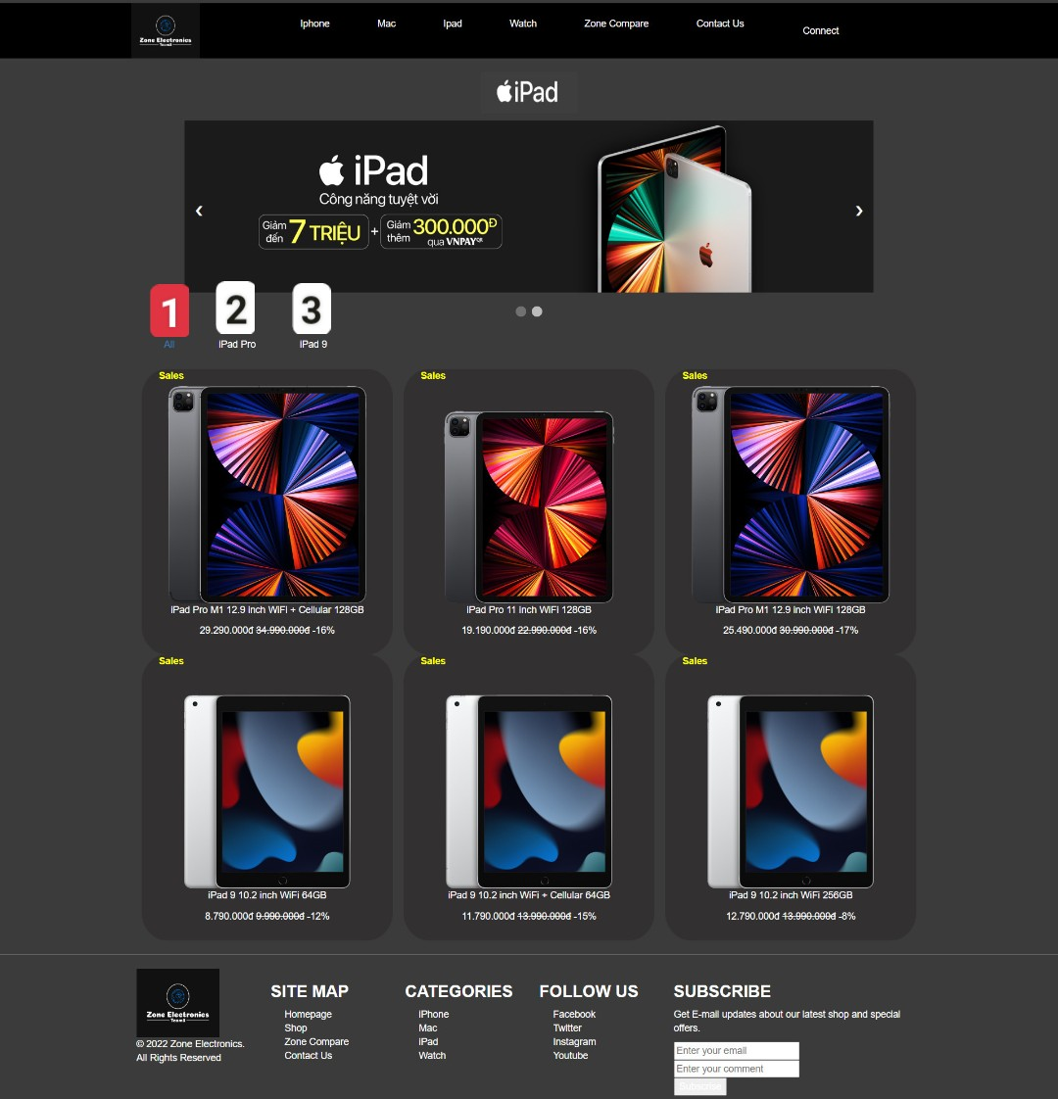

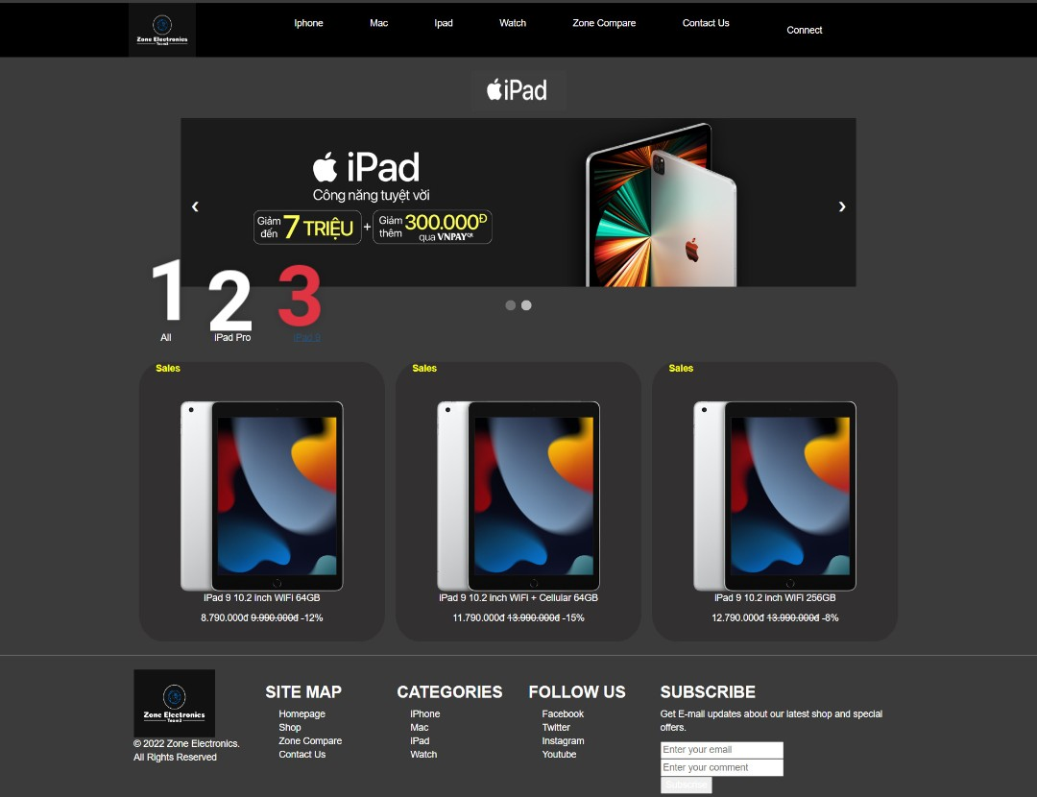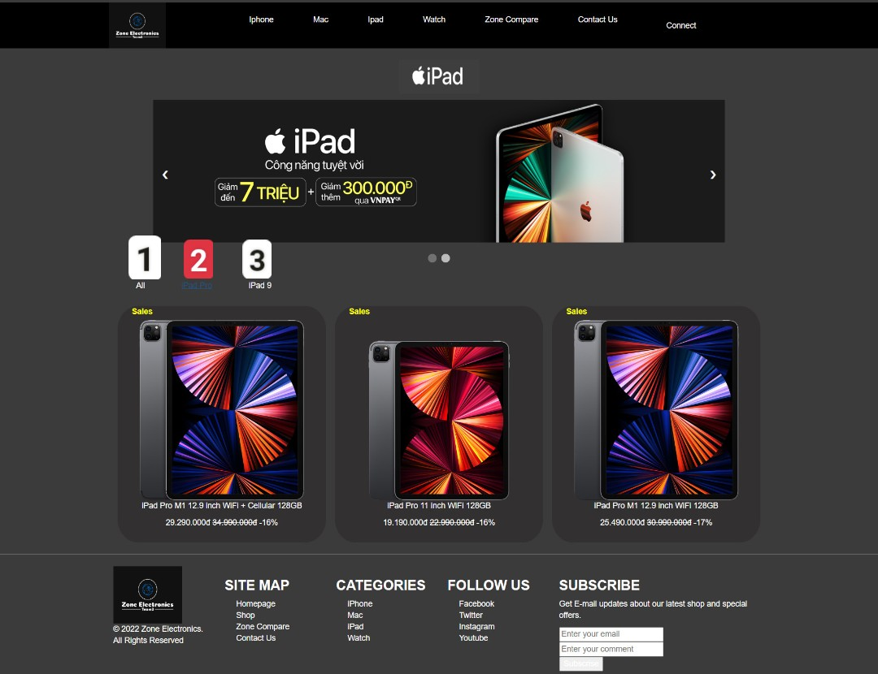

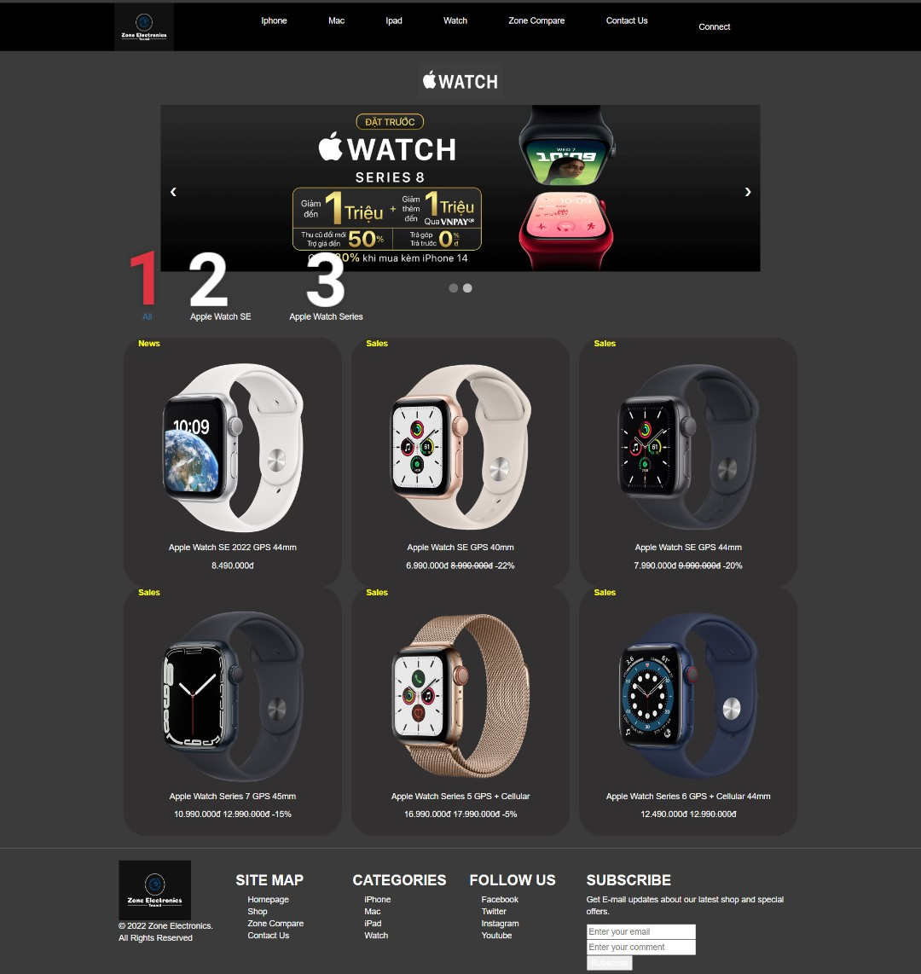**Watch**

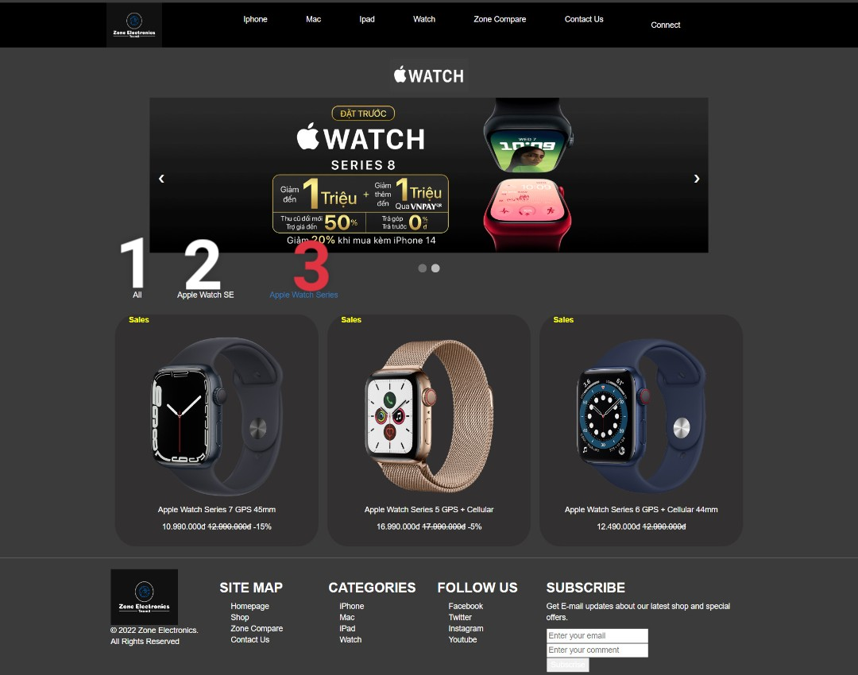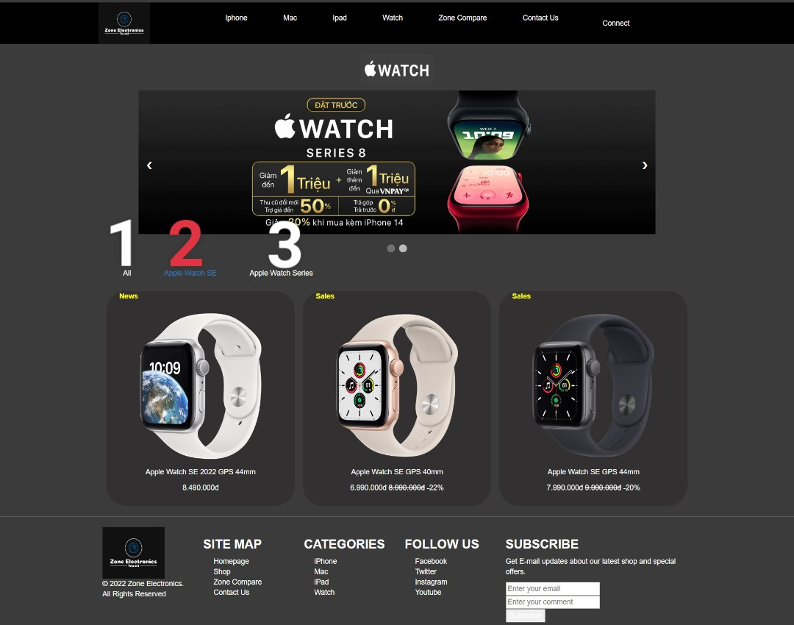

**III/Shop Details:**

**Description:**

This shop page displays the following information:  
- Show the detail of that item.

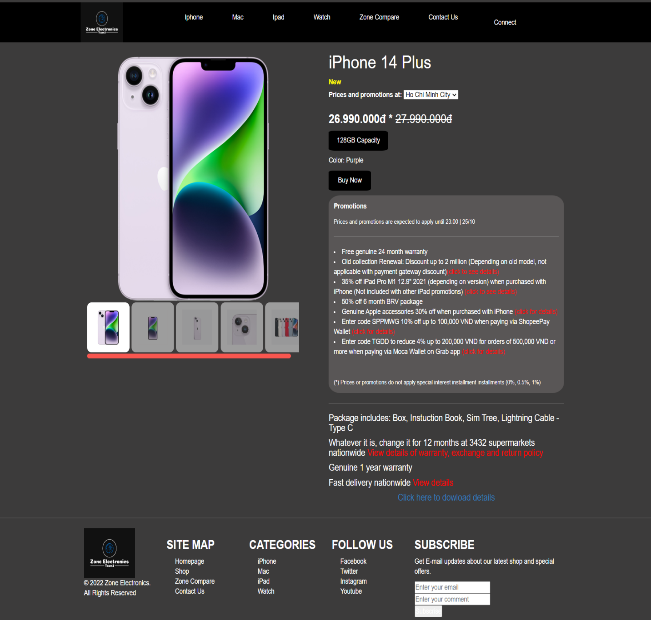**iPhone**

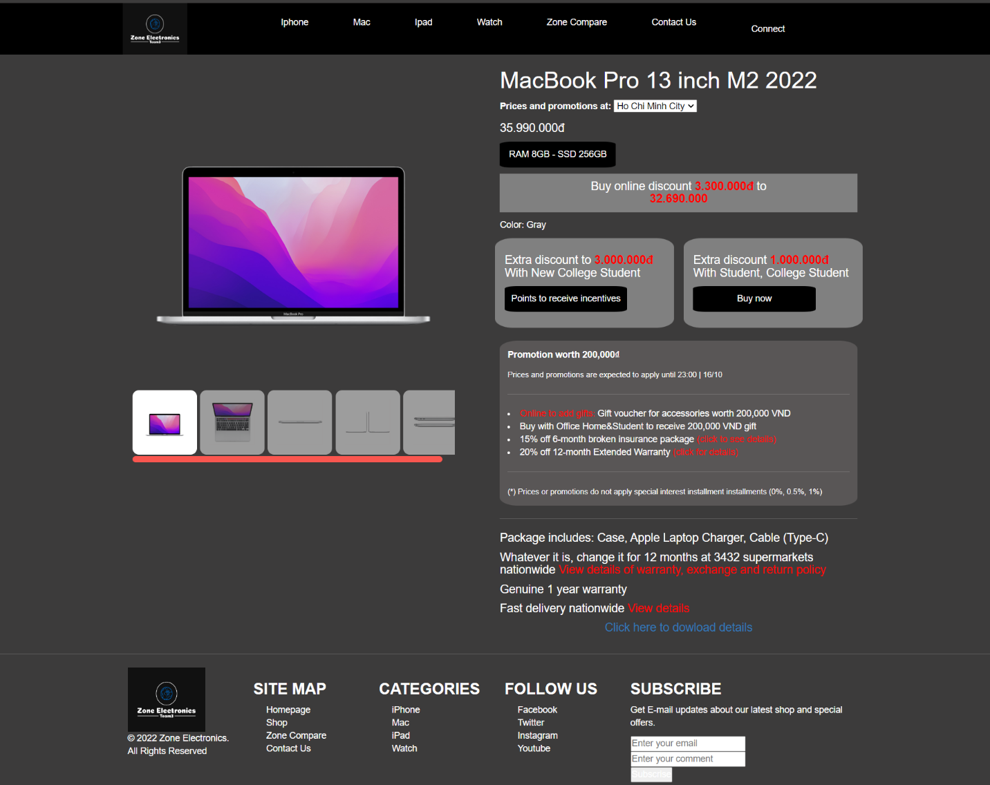**Mac**

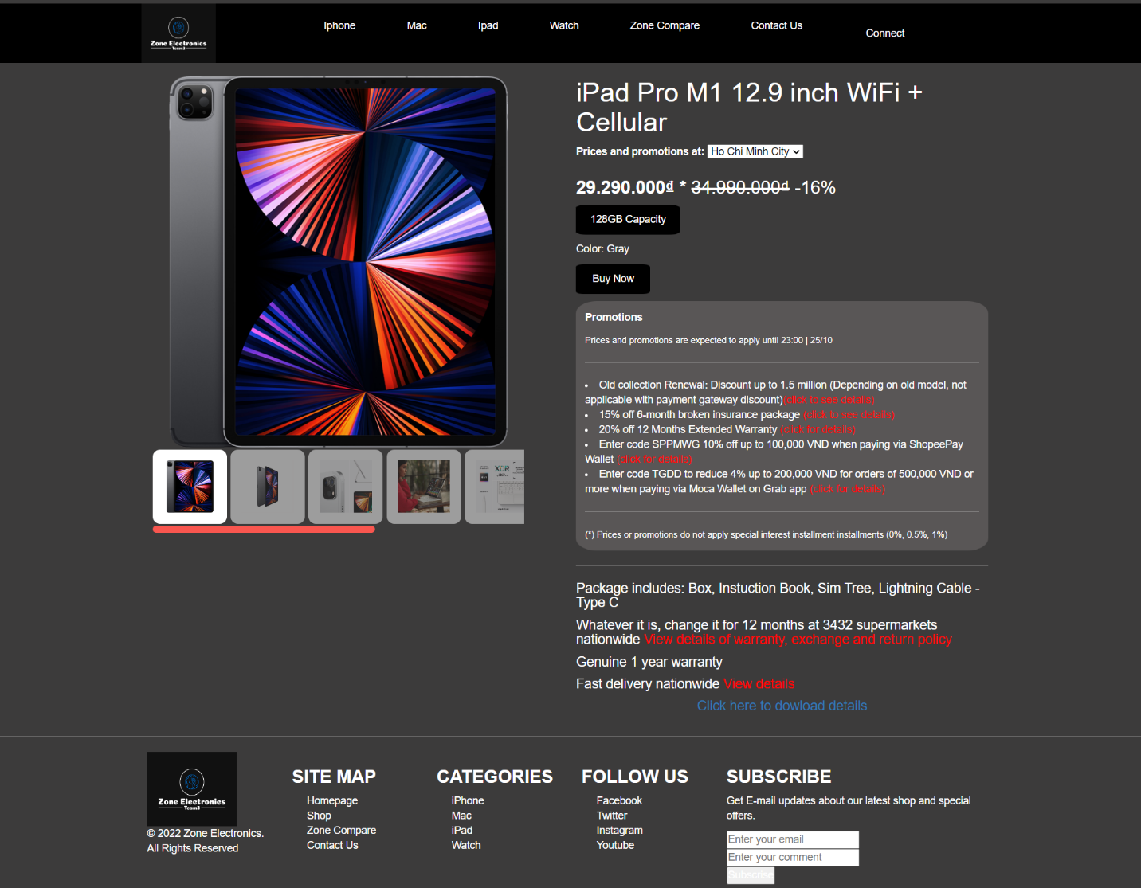**iPad**

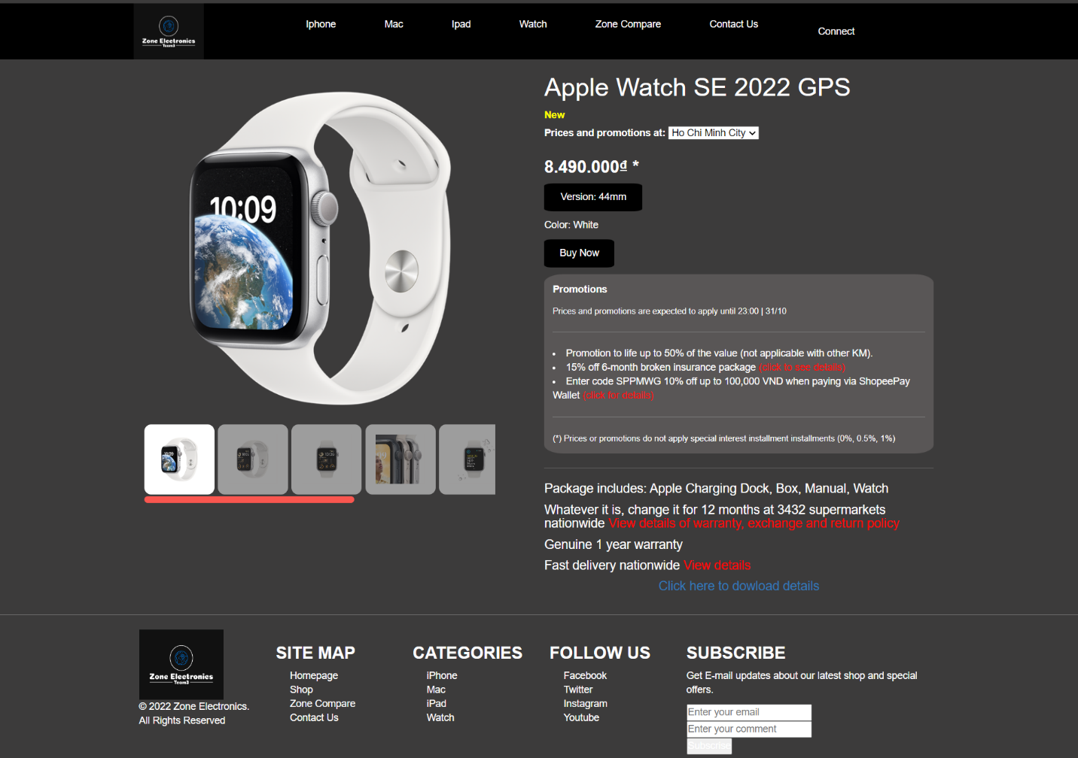**Watch**

**IV/Zone Blog:**

**Description:  
The blog page displays the following information:**  
- News.  
- Zone blog.  
- Events.

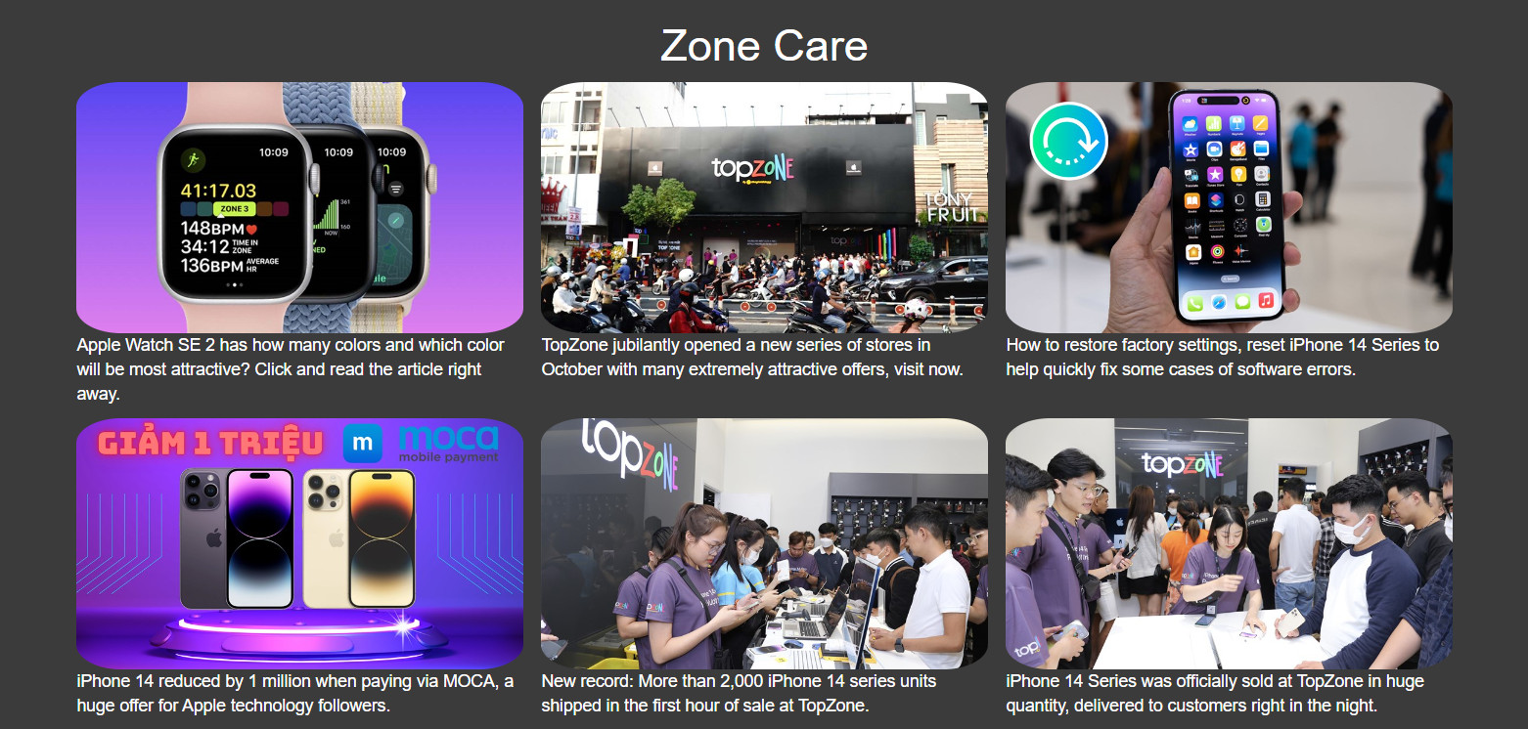

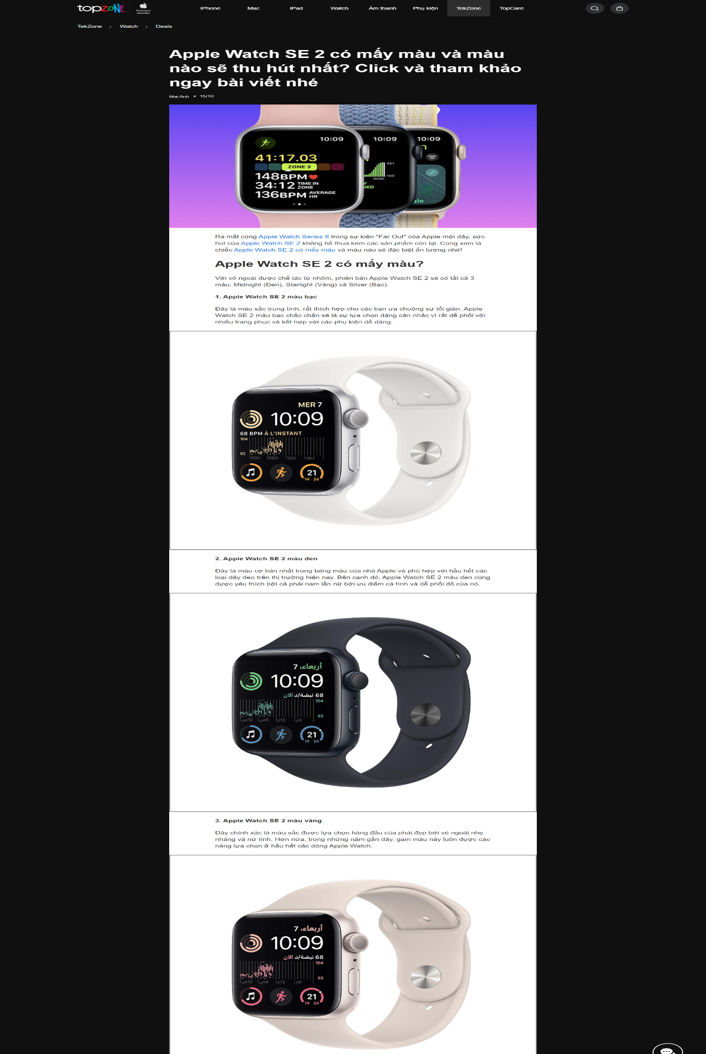

**V/Zone Compare:**

**Description:**

**This page displays the following information:**

_ Divided into two sides with a product selection list.

_ Display product details.

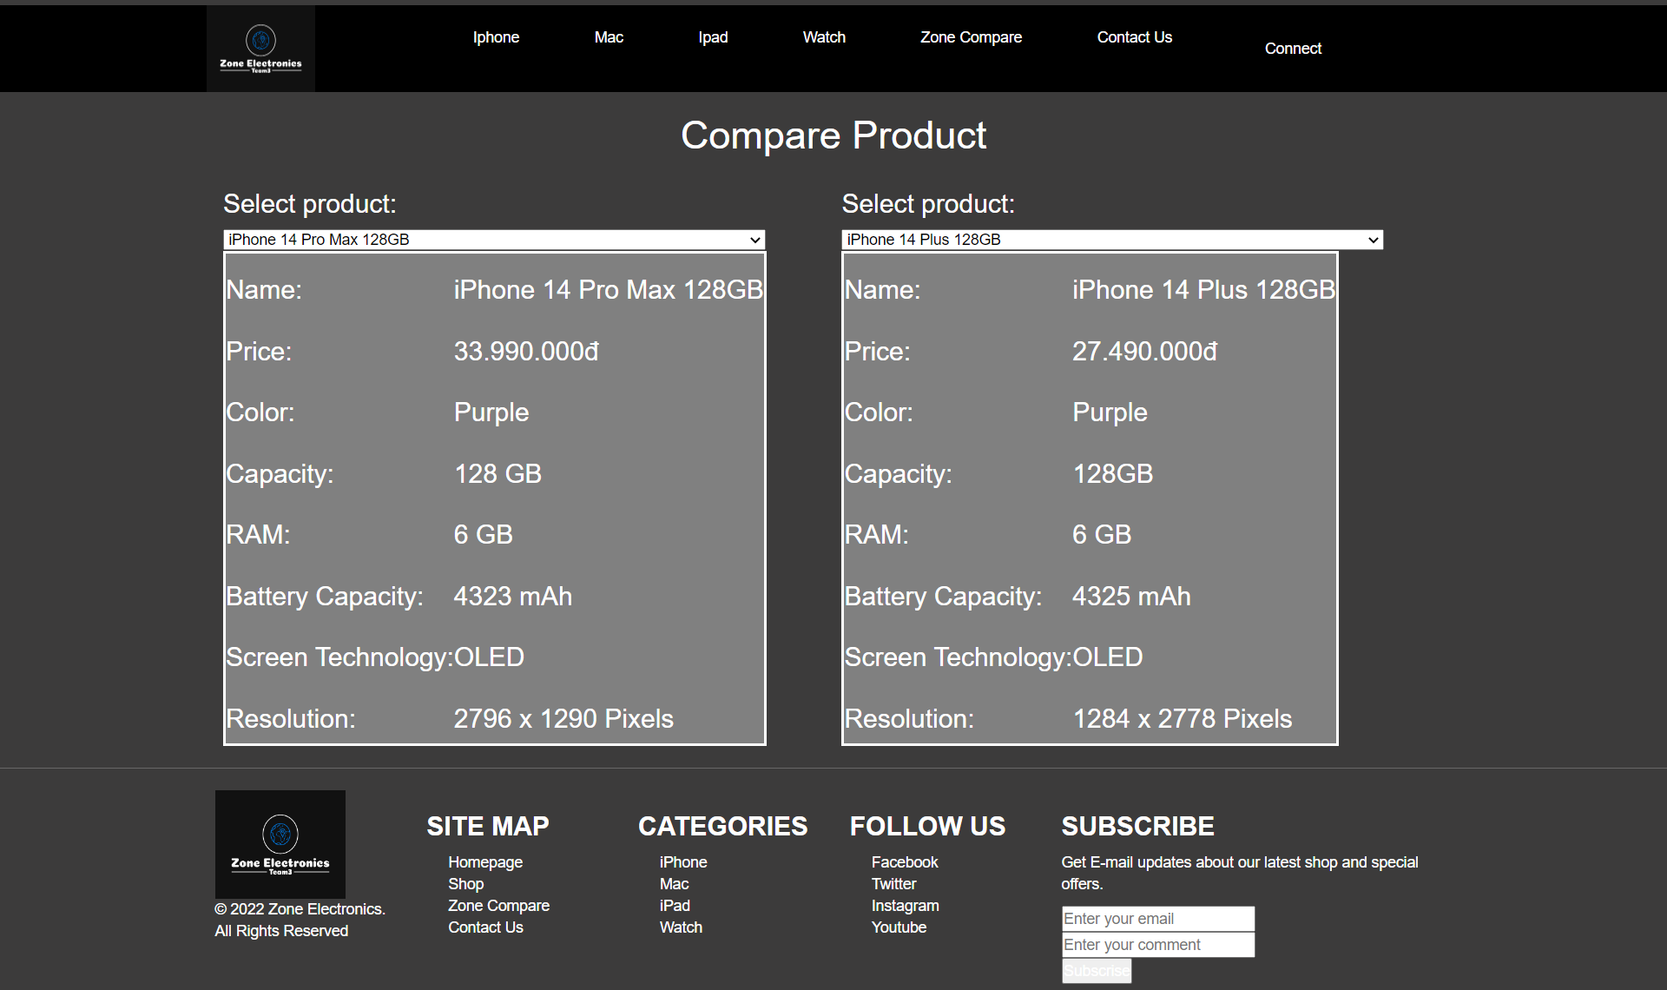

VI/Contact Us:

Description:

_ This page displays information about my team, GPS location, FPT APTECH Tel, Business Hours.

_ Can be feed back the comment.

_ Emai , Name , Message must be required.

_ When you have not entered the correct requirements and click the submit button, a message will appear.

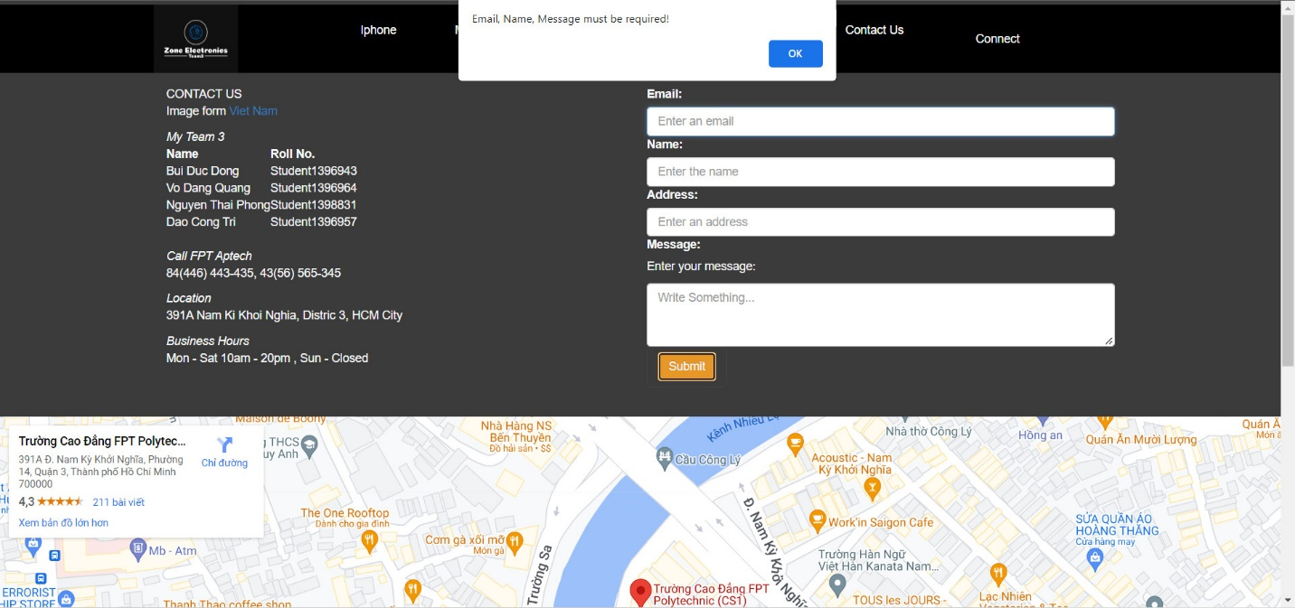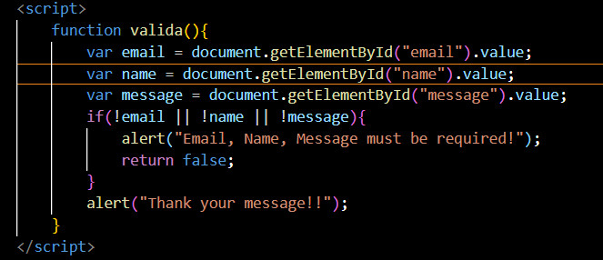_ Catch the event on the form as onsubmit = "valida()" and go down to the body using javascript to call the valida() function.

_ And when all has been entered, the successful submission shows the message.

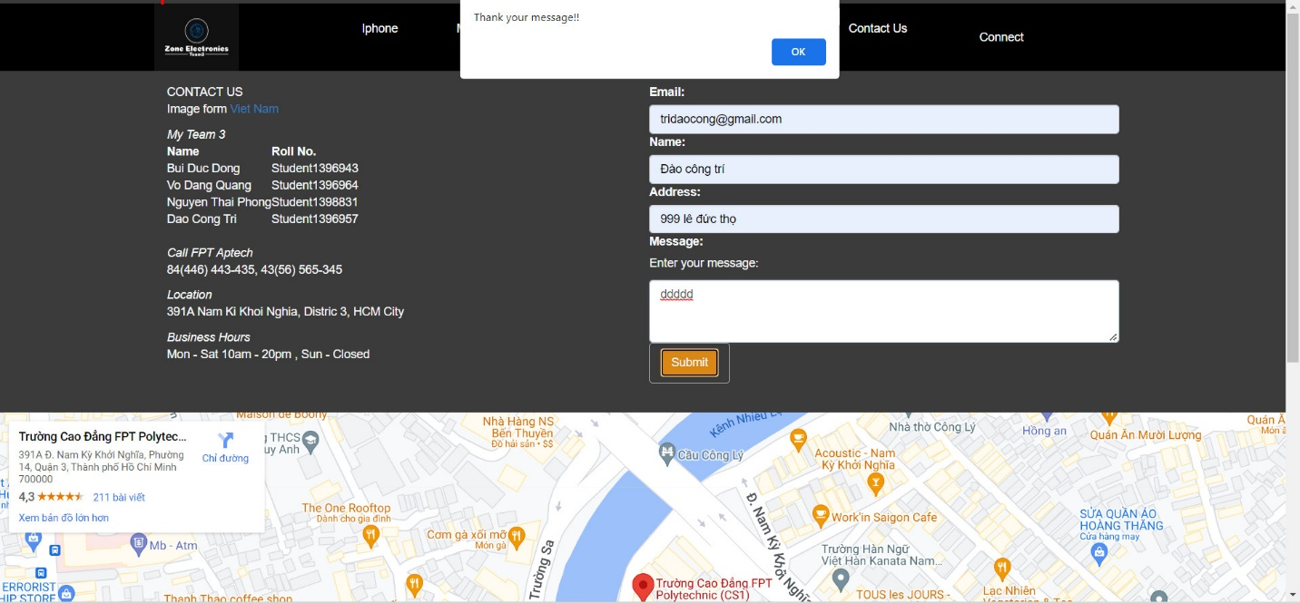

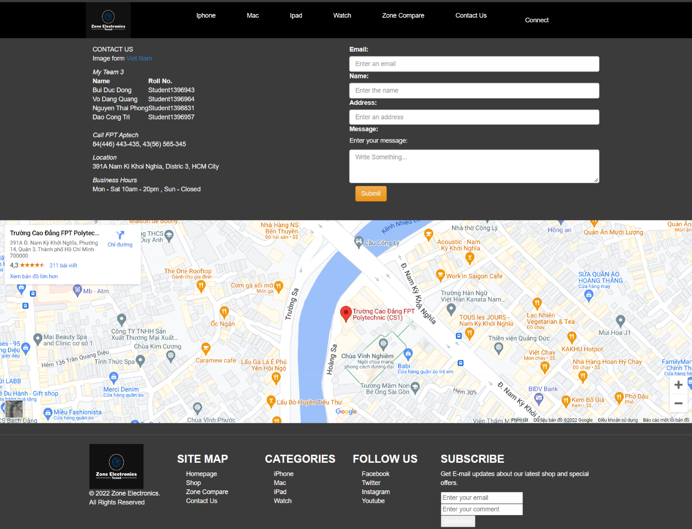

**VII/Connect:**

**Login and Register**

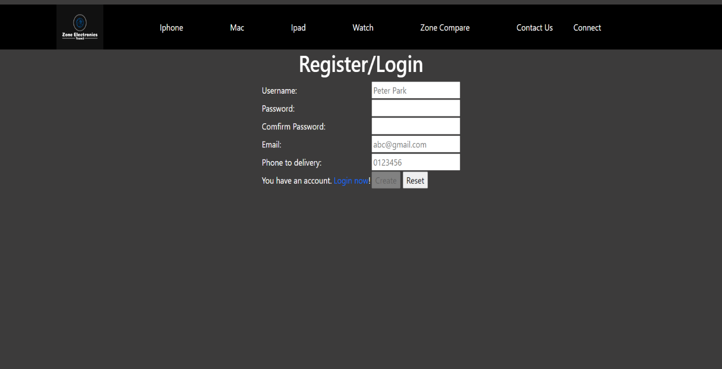

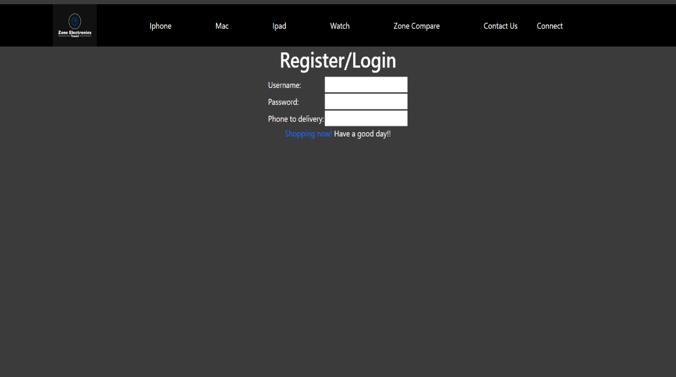

**TASKSHEET**

|  |  |  |  |  |
| --- | --- | --- | --- | --- |
| No. | Name | Work | Percent% | Day |
| 1 | Bui Duc Dong | Watch, Contact Us, Product details | 100% | 24/10/2022 |
| 2 | Vo Dang Quang | Sound, Add to cart | 0% |  |
| 3 | Nguyen Thai Phong | Accessories | 0% |  |
| 4 | Dao Cong Tri | Main Web, iPhone, Mac, iPad, Connect, Zone Compare | 100% | 20/10/2022 |